Jamie Kirby oxford university press
export educationadvisor@oup.com
Books International Aid
Malawi national library service-1 million books?
Which schools, whose in charge, can we meet them, can we request books?
Presentations St Johns and others.
HMRC: £12,000 £962.00
1st school signs up to Bradford Schools Supports Malawi Schools Appeals. BSSMSA
BRADFORD APPEAL for books and buildings
Bradford Book Appeal

Malawi Children’s Book Appeal
Bradford
https://bookaid.org/support-us/world-book-day/
Books – Where from – Source
Which levels 1 – 6
Invoices
How pay trustee?
Car?
Presentation Together
Website Funkynoodle
CharChar Trust
Thankyou letters
£1000
Check which is missing legacy
School Wide Project – Build a classroom – Give Books – Donations for
Usbourne books in Schools
Pay Btg teachers
Photocopier
Yendis fees
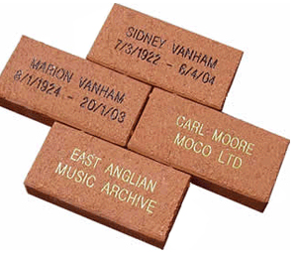
http://www.engravebricks.co.uk/
01730 895 971
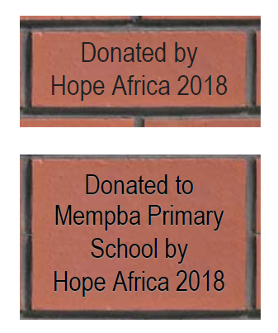
Tutoring Each school have 100 books in Bradford
No of schools in Malawi/Bradford
https://www.rippleafrica.org/education-in-malawi-africa/general-education-in-malawi-africa
https://borgenproject.org/10-facts-education-in-malawi/
http://starfishmalawi.com/education-in-malawi/
https://www.unicef.org/malawi/development_15943.html
https://www.epdc.org/sites/default/files/documents/EPDC%20NEP_Malawi.pdf
how many schools in Blantyre
- South West Division (Chikwawa, Blantyre Rural, Blantyre Urban,Mwanza, Nsanje)
http://www.fedomamalawi.org/public/themes/Fedoma/downloads/education_statistics_2012.pdf
1.3 Adult literacy rates: Malawi = 63; Urban =84.7; Rural = 15.3
Primary enrolment 4.18 m 2012 260,081 secondary
359,000 1964
55265 teachers
Pupil classroom ratio 107
Survival rates: Standard 5 58% for girls and boys
Standard 8 41 boys and 35 girls
Ramry leaving rates 205739 compared to 4.18 enrollment?

Total schools primary 5405 4985 rural 420 urban
36370 trained teacher
47708 teacher in total so 11000 not trained????
15% no classrooms 15% of 34569

Swed
646 schools 541 rural 105 urban
399477 pupils5694 teachers
Pupil ratio 111
Blantyre rural 161 schools
City 88
Std 1
Boys 12366 girls 12121
Std2
Boys 10087 10132 girls
5619 boys 5611 girls that finish std8
Drop rate 11 boys 14 girls at end if std 1
14 boys 26 girls std8
78/942 classrooms are temporary
151 / 156 borehole water and 4 no water
12/156 with electricity the rest no electricity
50% of boys toilets are under construction or a pit latrine with few handwashing facilities

Repetition rates
Boys and girls 21% std 1
Repeaters from std 1 is huge 2527 2670 blantyre rural
44424 children sen no provision
21 21 19 19 22 19 18 16 17 16 14 14 14 13 16 17
5261 in std 8 drop out pregnancy
Huge dropout family responsibility
Blantyre Rural 751 342 728 327 649 273 607 271 924 287 734 303 692 255 717 268 631 280 704 246 586 223 572 204 447 181 425 173 377 180 369 189 Add total number of orphans blanrtw rural

How many in Bradford 166 http://schoolswebdirectory.co.uk/leasearch.php?lea=Bradford&where=1&submit=Submit
Teacher Training

